**How to write and execute query:**

1.Click on open blank Query tab button right top(look at red rectangle )

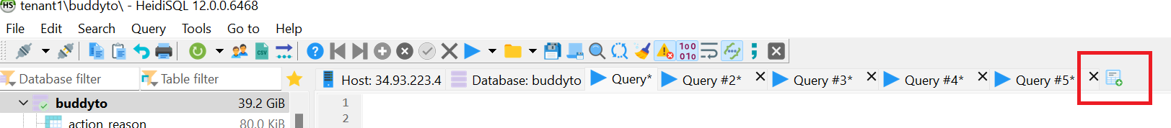

2.Write your query in the space opened.

3.Click on execute button on Menu as shown below (red rectangle)

